# GIT HANDSON-5

**Checkout my Gitlab:** [**https://gitlab.com/syamprasad-111-group/gitdemo**](https://gitlab.com/syamprasad-111-group/gitdemo)

Explain how to clean up and push back to remote Git without symbols  
**Step 1:** Verify if main is in clean state  
**Step 2:** List out all available branches  
**Step 3:** Pull the remote git repository to the main  
**Step 4:** Push the pending changes to the remote repository  
**Step 5:** Observe if the changes are reflected in the remote repository

**Step 1:** Verify if main is in clean state

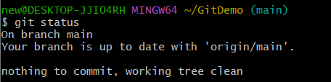  
  
**Step 2:** List all available branches

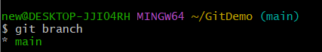  
  
**Step 3:** Pull the latest changes from remote

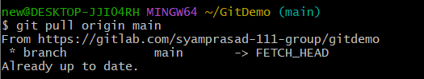  
  
**Step 4:** Push your local changes to remote

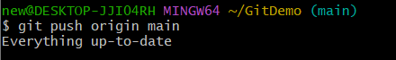

**Step 5:** Verify changes on remote

